#VISUALIZATION in Python

import matplotlib.pyplot as plt

fig = plt.figure("Histogram")

ax = fig.add_subplot(1,1,1)

ax.hist([21,12,23,35,45,60,33,22,56,34,28,40,41],bins =7, facecolor = 'r', normed = True)

plt.title("Distribution")

plt.xlabel("Range")

plt.ylabel("Amount")

plt.show()

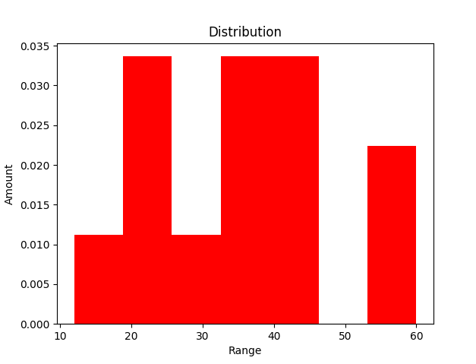

Code2

# fig = plt.figure('Box-plot')

# ax = fig.add_subplot(1,1,1)

# ax.boxplot([21,12,23,35,45,60,33,22,56,34,28,40,41])

# plt.show()

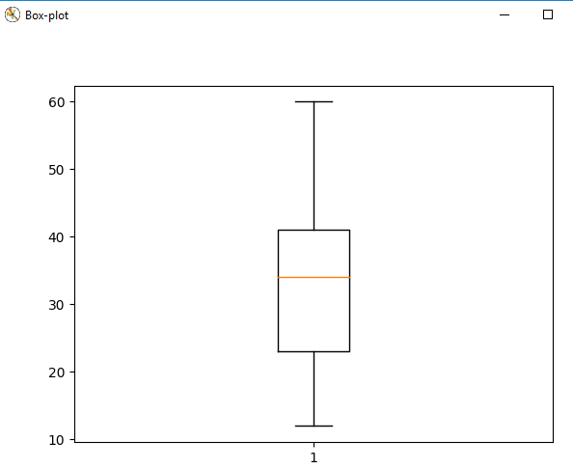

CODE 3

fig3 = plt.figure('Bar')

ax2= fig3.add_subplot(1,1,1)

ax2.set_xlabel('X')

ax2.set_ylabel('Y')

ax2.set_title("Bars")

ax2.bar([0,1,2,3],[5,10,15,5],[0.5,1,1.3,1],color=['b','r'])

plt.show()

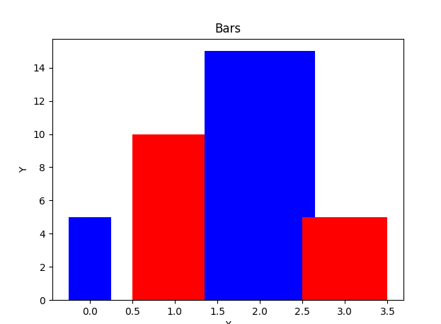

Code 4

fig4 = plt.figure('Line')

ax3 = fig4.add_subplot(1,1,1)

ax3.set_xlim([-2,10])

ax3.set_ylim([0,6])

ax3.set_xlabel('X')

ax3.set_ylabel('Y')

ax3.set_title("Lines")

ax3.plot([-1,2,4,7,8],[5,2,3,4,3],'r')

plt.show()

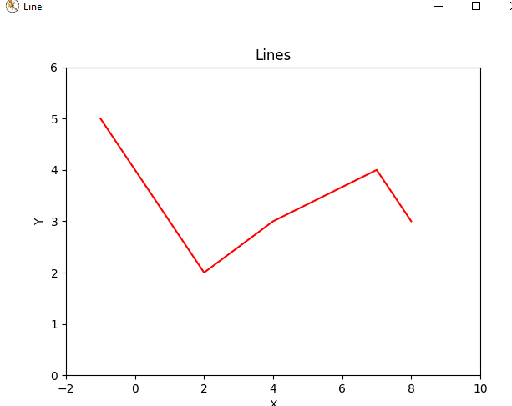

CODE 5

data = {'Player':['Wade', 'James', 'Kobe','Curry' ],

'First':[10,10,8,12],

'Second':[12,8,13,8],

'Third':[15,12,8,8],

'Fourth':[18,20,15,8]}

fig5 = plt.figure('Stacked bar')

ax4 = fig5.add_subplot(1,1,1)

bar_width = 0.5

bars = [i+1 for i in range(len(data['First'] ))]

ticks = [i + (bar_width/2) for i in bars]

ax4.bar(bars,

data ['First'],

width = bar_width,

label = 'First Quater',

color = '#AA5439')

ax4.bar(bars,

data['Second'],

width = bar_width,

bottom = data['First'],

label = 'Second Quarter',

color = '#FFD600'

)

ax4.bar(bars,

data ['Third'],

width = bar_width,

bottom = [1+j for i, j in zip(data['First'],data['Second'])],

color = '#FF9200'

)

ax4.bar(bars,

data['Fourth'],

width = bar_width,

bottom = [i+j+k for i,j,k in zip(data['First'],data['Second'],data['Third'])],

label = 'Fourth Quarter',

color = 'r')

plt.xticks(ticks,data['Player'])

ax4.set_xlabel("Total")

ax4.set_ylabel("Player")

plt.legend(loc = 'upper right')

plt.xlim([min(ticks) - bar_width, max(ticks)+bar_width])

plt.show()

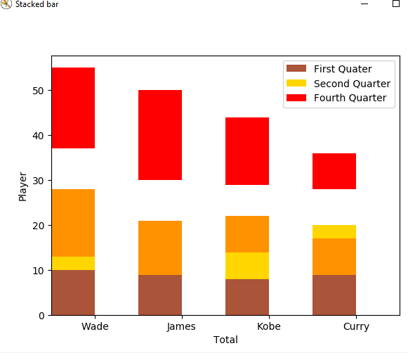

data = {'Player':['Wade', 'James', 'Kobe','Curry' ],

'First':[10,10,8,12],

'Second':[12,8,13,8],

'Third':[15,12,8,8],

'Fourth':[18,20,15,8]}

fig5 = plt.figure('Stacked bar')

ax4 = fig5.add_subplot(1,1,1)

bar_width = 0.5

bars = [i+1 for i in range(len(data['First'] ))]

ticks = [i + (bar_width/2) for i in bars]

ax4.bar(bars,

data ['First'],

width = bar_width,

label = 'First Quater',

color = '#AA5439')

ax4.bar(bars,

data['Second'],

width = bar_width,

bottom = data['First'],

label = 'Second Quarter',

color = '#FFD600'

)

ax4.bar(bars,

data ['Third'],

width = bar_width,

bottom = [1+j for i, j in zip(data['First'],data['Second'])],

color = '#FF9200'

)

ax4.bar(bars,

data['Fourth'],

width = bar_width,

bottom = [i+j+k for i,j,k in zip(data['First'],data['Second'],data['Third'])],

label = 'Fourth Quarter',

color = 'r')

plt.xticks(ticks,data['Player'])

ax4.set_xlabel("Total")

ax4.set_ylabel("Player")

plt.legend(loc = 'upper right')

plt.xlim([min(ticks) - bar_width, max(ticks)+bar_width])

plt.show()

code: I don’t know the number

fig8 = plt.figure('Pie')

sizes = [50,50,44,36]

labels = ['wade','james', 'kobe', 'curry']

explode = (0.1,0,0,0)

color= ['red','purple', 'yellow', 'blue']

plt.pie(sizes, explode = explode, labels=labels, colors=color,autopct='%1.1f%%',shadow =True, startangle=140)

plt.axis('equal')

plt.show()

